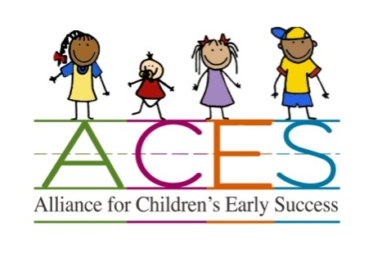
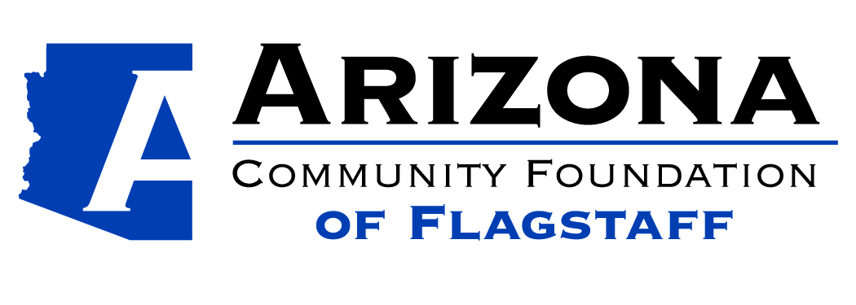

Alliance for Children’s Early Success (ACES)
Quality Improvement Grant Application

Applicant Information:

Program Name: ____________________________________________________________________

Contact Name: _____________________________________________________________________

Street Address (including city and zip code):____________________________________________
___________________________________________

Mailing Address (if different from above): ____________________________________________
____________________________________________

Phone Number/s: _________________________________________________________

Email Address: ___________________________________________________________

What motivated you to participate in this process?

How did you learn about this grant opportunity?

General Information about Your Program
Your Program is Currently (Check all that apply):
___DES Certified Child Care Home (Provide Copy of Certification with Application)
___DHS Certified Child Care Group Home (Provide Copy of License with Application)
___DHS Child Care Center (Provide Copy of License with Application)
___DES Child Care Subsidy Contracted
___Supports Families with limited resources
If yes, please describe what support you provide: _____________________________________________________________________________
___ Currently participating in a quality improvement grant through (check all that apply):
  - ___ Arizona Self Study b.___Quality First
  - If no, have you applied for Quality First? _____ Are you interested in learning more?
____Accredited by _____________________ (Provide copy of Accreditation Certificate with Application)
Information About the Children You Serve
- What is the capacity of your child care program? ______________________________
- Average Daily Enrollment: ________________
- What age groups do you serve? __________
- Number of children with special needs you serve: _______
Describe the special needs: _____________________________________________________

Quality Improvement Grants
- Grant requests up to $625.00 will be considered
- Grants must help to maintain or obtain child care certification or licensure
- Grants must identify the certification/licensing requirement and/or AZ Learning Standard or Infant Toddler Guideline the grant will impact
- Applicants who did not receive funding last year will have priority

How do you plan to use the Grant Funds
The following questions may be answered on a separate sheet of paper if additional space is needed.

How do you plan to use the grant funds?
Please provide a breakdown of how the funds requested will be spent. For your convenience there is a blank chart below. You may also submit an invoice of projected expenses.

Which certification/licensing requirement or AZ Early Learning Standard or Infant and Toddler Guideline will this grant impact?

How will these purchases improve the quality of your program?

Breakdown of Grant Funds Requested

Area of Improvement | Specific Materials/Resources/Trainings Requested | Vendor | Total Cost
 |  | Subtotal:
 |  | Tax if applicable:
 |  | Shipping if applicable:
 |  | Total amount requested:

I agree to submit receipts for quality improvement purchases and provide a summary of how the grant helped to increase quality and a photo by 4/30/16 if I receive a grant.

________________________________________________ _______________________
Signature Date

Only applicants within FUSD geographic boundaries are eligible
Applications are due by January 31, 2016
We are here to help! If you need assistance with this application or have any questions, please contact Paula Stefani pstefani@asccaz.org OR 928-714-1716

