Name | Title and Agency | County | Email
Sandi Cimino | Writer/Speaker/Coach  (Independent Contractor) | Maricopa | sandi.cimino@gmail.com
Yvette Corral | Outreach Coordinator  Pima County Health Department | Pima | yvette.corral@pima.gov
Emily Flanigan | Program Specialist  Phoenix Children’s Hospital | Maricopa | eflanigan@phoenixchildrens.com
Bertha Fuentes | Healthy Families Supervisor  Healthy Families Yuma | Yuma | bfuentes@cfraz.org
Patricia Garcia | Program Supervisor  Healthy Families | Yuma | pgarcia@cfraz.org
Lucy Garcia | Family Program Coordinator  Northland Family Help Center | Coconino | LGarcia@northlandfamily.org
Sara Guerra | Amberly’s Place Family Advocacy Center | Yuma | sara@amberlysplace.com
Sharon Listiak | Home Visiting Coordinator  Gila County | Gila | slistiak@gilacountyaz.gov
Claire Louge | Training and Outreach Manager  Prevent Child Abuse Arizona | Yavapai | claire@pcaaz.org
Christy Maltos | Outreach Coordinator  Child and Family Resources | Graham/  Greenlee | cmaltos@cfraz.org
Paula Mandel | Nurse Supervisor  Pima County Health Department | Pima | paula.mandel@pima.gov
Jannelle Radoccia | Lutheran Social Services of the Southwest | Maricopa | jradoccia@lss-sw.org
Brandi Samaniego | Healthy Families  Child and Family Resources | Cochise | bsamaniego@cfraz.org
Michelle Simmons | Healthy Steps  North Country Health Care | Navajo/  Coconino | msimmons@nchcaz.org
Amy Stradling | Home Visiting Coordinator  Navajo County Public Health | Navajo | Amy.Stradling@navajocountyaz.gov
Denise Voiles | Nurse Supervisor  Maricopa County Department of Public Health | Maricopa | denisevoiles@mail.maricopa.gov
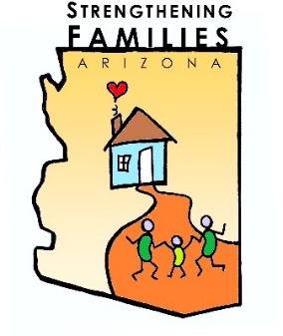
Strengthening Families™ is a research-based approach to working with families in a way that develops and enhances their strengths. It is based on engaging families, programs and communities in building five protective factors: Parental resilience; Social connections; Knowledge of parenting and child development; Concrete support in times of need; and Social and emotional competence of children.
a project of
The following trainers are certified to offer trainings on the Strengthening Families™ Protective Factors:
Project funded by:

